Part A: Project Scope and Requirements

Section 1: Problem Statement

1.1.a. Problem & Need

In an increasingly digital world, where virtual interactions and digital devices dominate, there is a growing challenge of isolation and difficulty in forming meaningful connections, particularly among introverted individuals. The new generation faces heightened barriers to social interaction and often struggles to bridge the gap between the digital and physical world. This leads to a pressing need for a solution that facilitates genuine connections in the digital age.

Nevertheless, we have discovered a solution to this problem. Whether you are a person who is still unmarried at the age of 35 and eagerly wants to start a family or a teenager whose sole focus is console gaming and desires a gaming partner, our app, MingleNest, offers the ultimate solution. MingleNest provides a platform for individuals to connect with others, ensuring safe and secure conversations. Our matching algorithm functionalities enable users to connect with those who pique their interest and more.

1.1.b. List of Capabilities and Benefits

I) Capabilities

1. User Profile Creation: Users could construct complete profiles of themselves, their hobbies, and their preferences.

2. Matching Algorithm: The software uses advanced matching algorithms to make suggestions for potential mates based on a variety of compatibility criteria, such as shared interests, geography, and more.

3. User Discovery: Users can go through and find profiles of both well-known and unfamiliar people, enhancing their social networks.

4. Communication & chatting: Mingle Nest's text, audio, and video chatting options make it simple for users to communicate with one another.

5. Privacy Control: Users can limit the display of their profiles and conversations by changing their privacy settings, which gives them control over their privacy.

6. Search Filters: Users can limit probable matches based on details like age, location, and interests using advanced search filters.

7. Real-time Notifications: To keep users interested, the app gives real-time notifications for new messages, profile views, and event updates.

8. Safety Feature: To provide a safe and courteous environment, Mingle Nest uses safety precautions including profile verification and reporting mechanisms.

9. Payments: The payment option enables users to gain access to premium features by purchasing a Premium Pass. The Payment Option Capability improves the Mingle Nest experiences like Premium Calling and Messaging and Increased Profile Visibility.

I) Benefits

1. By bridging the distance between acquaintances and complete strangers, Mingle Nest promotes new connections and solidifies already-existing ties.

2. Users can enhance their social life by growing their social networks, meeting new people, and maintaining connections with friends and acquaintances.

3. By matching users with compatible people, the program increases the likelihood that users will form long-lasting relationships.

4. Users' profiles and interactions are under their control, assuring their privacy and safety while using the service.

5. The software promotes in-person interactions, enabling users to escape their online solitude and form genuine connections.

6. The app's many communication methods, such as text, voice, and video chatting, make it easy and entertaining for users to have conversations and foster connections.

7. A safe and respectful environment is created through Mingle Nest's safety measures, such as profile verification and reporting procedures, which lower the likelihood of unpleasant interactions.

1.2 Stakeholders and their roles

* Users (“Mingle Nesters”)
* Customer Support Team
* Moderators
* Developers
* Marketing Team

1.3 Sub-systems of the application (Functional Components)

* Log in (Including login and password reset functionality)
* Registration Subsystems
* Profile Subsystem
* Matching Subsystem (Unknown Profile)
* Texting Subsystem
* Searching Subsystem (Known Profile)
* Settings Subsystem
* Reporting Subsystem
* Video Chat or Call Subsystem (For Premium)
* Unlimited Likes (For Premium)
* Advanced Matching Subsystem (For Premium)
* Profile Boost (For Premium)

1.4 Intended users of the SRS documentation.

* Software Design Architects
* Developers
* Product managers and Project managers

Section 2: General Overview Modelling

2.1 Context Flow Diagram (CFD)

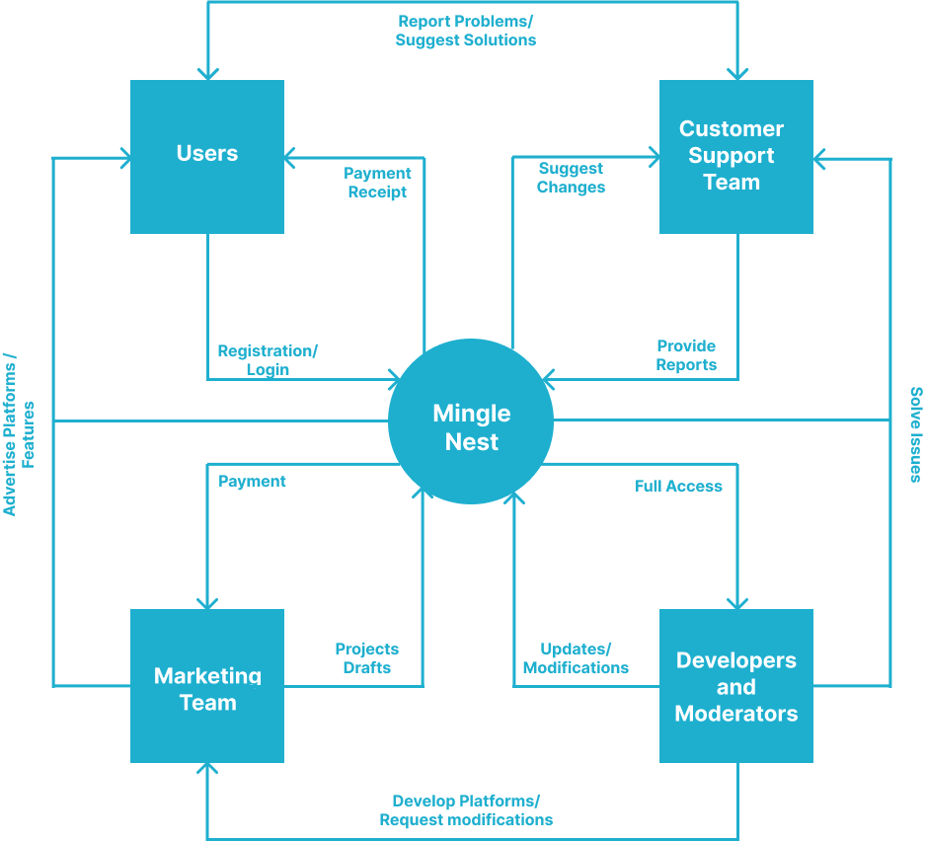

Section 3: Requirement - Functional and Non-functional & UML Use Case Modelling

3.1 Functional Requirements

|  |  |  |  |
| --- | --- | --- | --- |
| FR# | Name (Goal Use Case) | Role Player | Description |
|  |  |  |  |
|  |  |  |  |
|  |  |  |  |
|  |  |  |  |

3.2 Non-Functional Requirements

|  |  |  |
| --- | --- | --- |
| NFR# | Name | Description |
| NFR001 |  |  |
| NFR002 |  |  |
| NFR003 |  |  |
| NFR004 |  |  |
| NFR005 |  |  |